1. Create a teacher Table in university database.
2. The schema is ( Teacher_ID int , Name varchar ,Designation varchar, Departnebt varchar ,Credit_load int):

Command: CREATE TABLE teacher(Teacher_Id int, Name varchar(32), Designation varchar(32) ,Department varchar(32),Credit_load int) ;

1. Insert 20 random value in the teacher table :

The following command:

INSERT INTO teacher

VALUES

(1000201, 'Md. Ashikur Rahman', 'Lecturer','Software', 14),

(1000202, 'Saykot Shariar', 'Lecturer','Software', 16),

(1000203, 'Rayhan Rabby', 'Lecturer','Software', 15),

(1000204, 'Rajib mia', 'Professor','Software', 15),

(1000205, 'Nadia sultana', 'Senior Lectural','Software', 18),

(1000206, 'Maliha Mokless', 'Lecturer','Software', 14),

(1000207, 'Maliha sultana', 'Lecturer','Software', 14),

(1000208, 'Bibash', 'Lecturer','Software', 14),

(1000209, 'Nafij', 'Lecturer','Software', 14),

(1000210, 'Munna', 'Lecturer','Tourism', 14),

(1000211, 'Lizon', 'Lecturer','Software', 14),

(1000212, 'Alif', 'Lecturer','Software', 12),

(1000213, 'Hasib', 'Lecturer','Tourism', 14),

(1000214, 'Sihab', 'Lecturer','Software', 14),

(1000215, 'Rifat', 'Lecturer','CSE', 14),

(1000216, 'Emon', 'Lecturer','Software', 14),

(1000217, 'Lina', 'Lecturer','Software', 14),

(1000218, 'Shawon', 'Lecturer','Software', 14),

(1000219, 'Yousuf', 'Lecturer','Software', 14),

(1000220, 'Sadia', 'Lecturer','Software', 14);

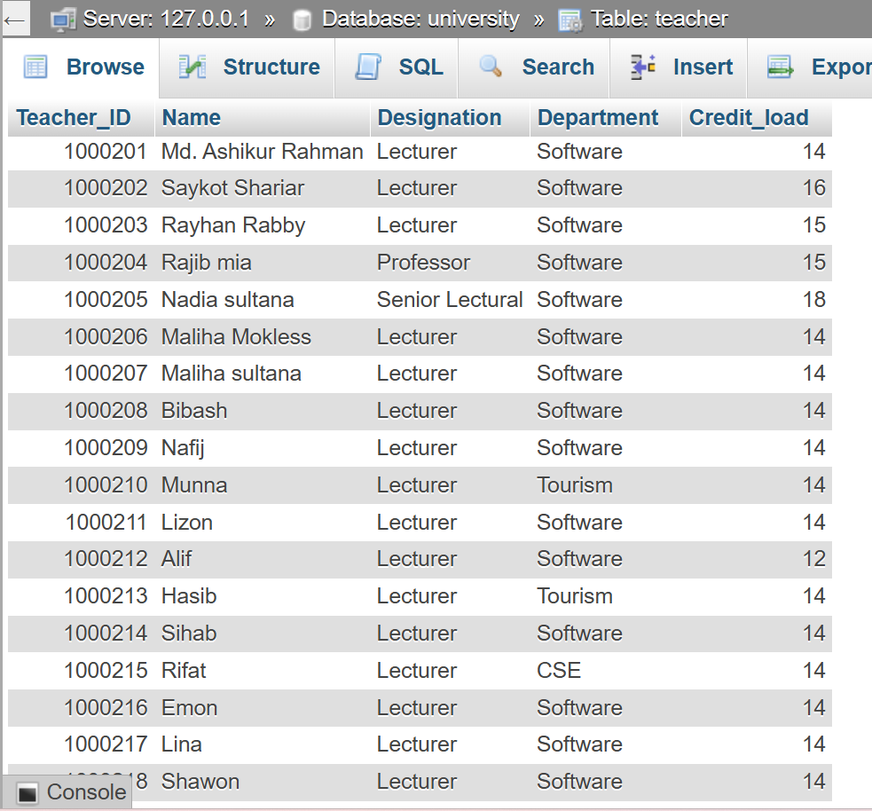

1. Add All student address:

Command : UPDATE students SET Address = 'Mirpur' WHERE Address IS NULL;

1. Sorting the student table based on the CGPA: The following code:

SELECT * FROM student ORDER BY CGPA DESC;

6.

SELECT AVG(Credit_load) FROM teacher;

7.

SELECT AVG(due) FROM student;

